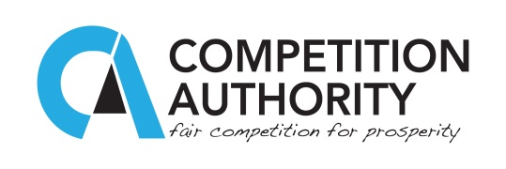

Press Statement 24th May 2016

SADC COMPETITION AUTHORITIES TO SIGN MEMORANDUM OF UNDERSTANDING

Heads of SADC Competition Authorities will on 26th May 2016, sign a joint Memorandum of Understanding for cooperation in the enforcement of competition laws. The signing ceremony will be held at Masa Square Hotel in Gaborone, Botswana at 17:30 Hours.

The Mou signing will be preceded by the Seventh Meeting of the SADC Competition and Consumer Law and Policy Committee, which was established in 2009 following the SADC Heads of States Declaration on Regional Cooperation in Competition and Consumers Policy of 2008. The committee comprises of CEO’s of SADC competition authorities and was established primarily to foster cooperation and dialogue in the enforcement of competition and consumer laws in recognition of the important role such policies can play in promoting economic laws in recognition of the important role such policies can play in promoting economic growth and development in the region.

The ceremony will be a historic event that marks an important milestone in augmenting initiatives towards the liberalisation and integration of markets. The initiative provides a framework for competition authorities to harness the collective efforts in addressing competition issues arising from cross border anti-competitive practices, which practices, are a threat to the benefits of trade liberalisation and integration of markets.

